- Bluebook Page116 November 2018 variant one examination:

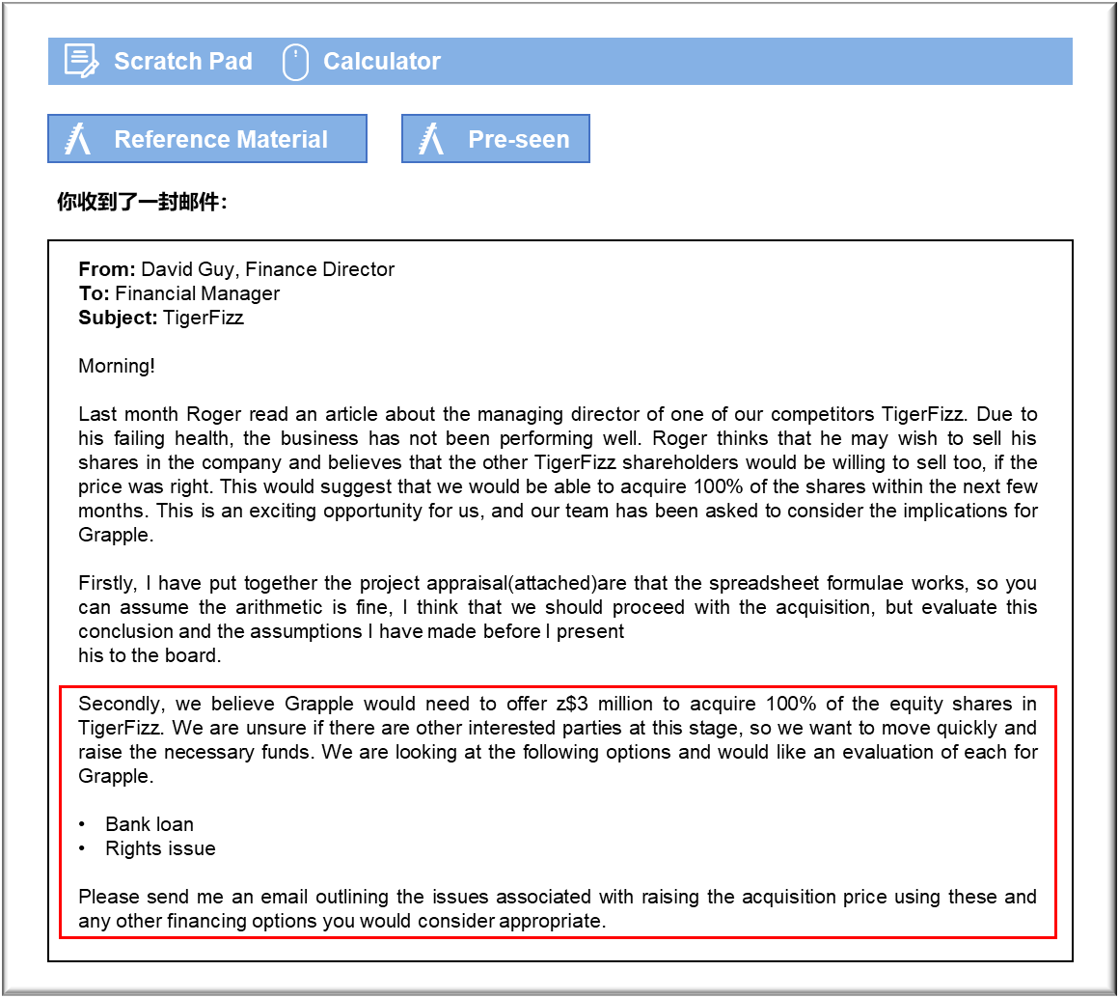MANAGEMENT CASE STUDY NOVEMBER 2018 EXAM ANSWERS

Variant1 Task1
These answers have been provided by CIMA for information purposes only. The answers created are indicative of a response that could be given by a good candidate. They are not to be considered exhaustive, and other appropriate relevant responses would receive credit.

CIMA will not accept challenges to these answers on the basis of academic judgement.

Project appraisal
The conclusion that the investment appraisal for the acquisition of TigerFizz, using the
net present value method, is positive and therefore worthwhile is correct. The positive
amount is assumed to be the increase in the shareholder wealth. However, it is worth
noting that the amount is Z$0.3 million and Grapple is paying Z$5.1 million in the first
two years to acquire this. This is not a high return on investment. If any one of the
elements of the appraisal calculation is incorrect this may lead to the outcome being
negative and we should consider the likelihood of this occurring.
Sensitivity analysis should be performed to determine how much each of the inputs
would need to change before the net present value of this project becomes negative.
Taking each element individually we would determine how much a change in
percentage terms it would be if any of the costs were to increase by Z$0.3m. For
example, for the fixed costs Z$0.3m/Present value of fixed costs x 100%. This could be
applied to restructuring costs, revenue and variable costs too. Sensitivity analysis
suggests the critical factors for the board to review but it does not provide a probability
of the chance of this happening.
In addition, the board may find that the competitive advantage period is less than 5
years and so the amount of net cash inflows generated over that time is less than the
calculation suggests. It is not clear how the competitive advantage will arise, especially
as we will still be much smaller than Party Pops and Carnival. A reduction in the actual
competitive advantage realised would reduce the net present value of the investment.
These answers have been provided by CIMA for information purposes only. The answers
created are indicative of a response that could be given by a good candidate. They are
not to be considered exhaustive, and other appropriate relevant responses would
receive credit.
CIMA will not accept challenges to these answers on the basis of academic judgement.
We have assumed that the cash flows occur at the year end. This is not realistic and
they would appear throughout the period. This may make the net present value slightly
higher.
Finally, we have used the weighted average cost of capital (WACC) to determine the
net present value of the project. This is only suitable if we going to raise finance that
keeps the gearing ratio constant over the next 5 years. This may not be so if we raise
additional finance to acquire TigerFizz. It also assumes that the business risk
associated with TigerFizz is the same as Grapple. This may be the case as they are in
the same industry although they are a different size. However, it is appropriate to use
WACC if the investment is relatively small in relation to our business. This is the case.
Grapple should consider looking at how long it will take for the investment to cover the
initial outlay. This project does not pay back until the final year, which could be
considered too risky. Overall the above should be considered before a final decision is made.
Long term sources of finance
Grapple needs to raise Z$3m to acquire TigerFizz.
Debt
Grapple is an unlisted entity. There may be some scope for issuing bonds but it is more
likely that a loan will be arranged through the bank.
The bank loan would increase the non-current liabilities and therefore the level of
gearing. A high gearing ratio may deter future investors as it is perceived as making
Grapple appear riskier than before. In addition, the bank will charge interest on a regular
basis. The rate of interest may be fixed or variable. This also adds an element of risk to
the lending. Finally, Grapple will need to make sure that there are sufficient funds to
repay the loan at the end of the term.
The loan may also have covenants attached which would restrict further borrowing or
impose repayment deadlines if conditions are breached.
Rights issue
A rights issue is offered to existing shareholders allowing them the right to acquire
shares in Grapple in proportion to their existing holding. The shareholders are family
members. They would need to be able to raise the funds privately in order to acquire the
shares. Given the lack of interest in Grapple of 40% of the shareholders, and the
previously expressed desire to raise personal funds, it may be unlikely they take up the
rights issue. Alternatively, they could sell their rights, but there may be a limited market
as Grapple is not listed, and it would mean that the control over Grapple would change.
November 2018 3 Management Case Study Exam
Issuing shares would increase equity and therefore reduce the gearing. This would
potentially make Grapple appear a less risky prospect for investors in the future. The
benefit of shares over debt is that dividends do not need to be paid each year, as they
are issued at the discretion of the directors. Also, the shares are irredeemable, so
investors are not expecting to be paid back.
Surplus cash
Grapple has cash reserves of approximately Z$2 million. If this was spent acquiring
TigerFizz, Grapple would only need to raise an additional Z$1 million by either loan or
through a share issue. The use of the cash would mean that the shareholders may not
receive a dividend this year and the cash may have been 'ear-marked' for other projects
which may not now proceed.
Other investors
Other external sources of equity finance may be available from new individual investors,
business angels and venture capitalists. New investors would expect to acquire equity
and this may provide an exit route for Roger should he decide to retire in the future.
Use of surplus cash and loans may be the best option for financing.

